This kit is designed by teachers, for teachers. It uses pieces from multiple Modeling Infection and Immunity Kits to show antibody-antigen interactions and how some viruses evade the immune response.
Link three membrane pieces together.
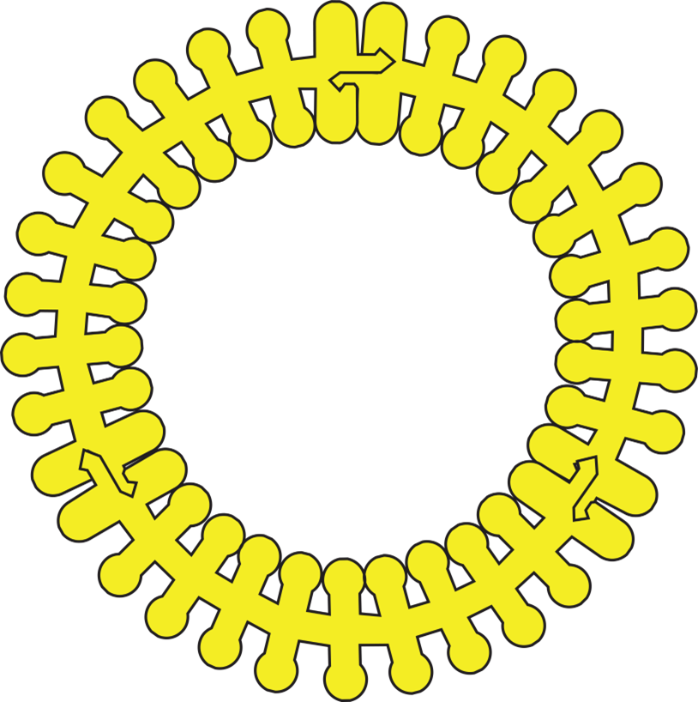
Form a circle with your membrane.
Add the viral surface proteins to your model. The example to the right shows the SARS-CoV-2 virus.
Add all your antibodies to discover that antibody C interacts with this protein.
What happens if there are mutations in the gene for the surface protein? How might this affect the infection cycle of the virus? Will the same antibody still interact with the surface protein?

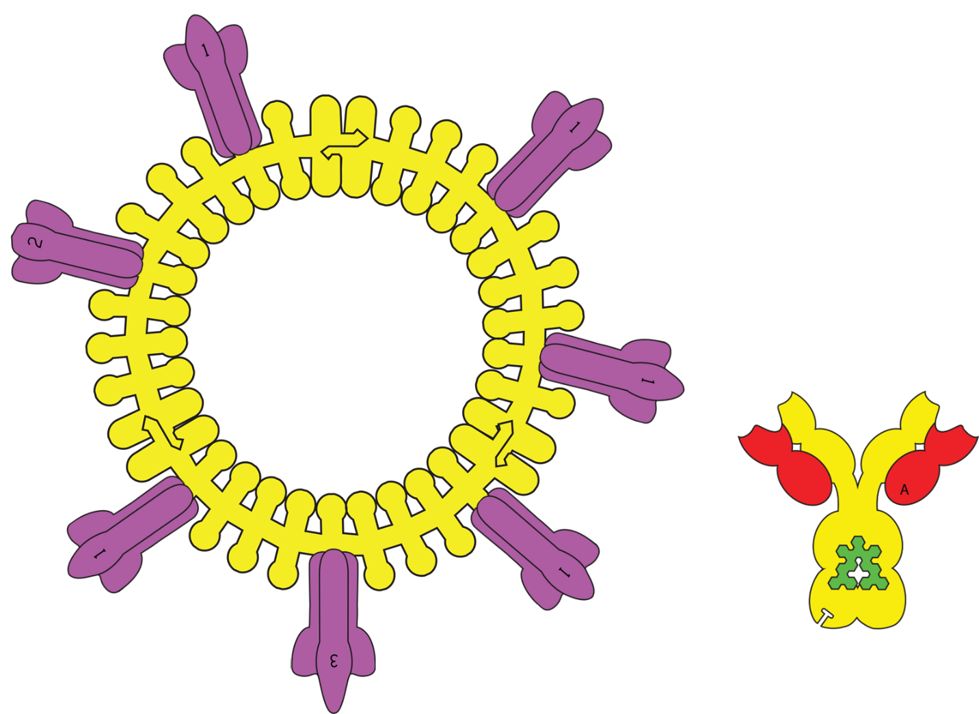
Model 2 - (Influenza)
You can also model influenza A with this kit using the components shown above.
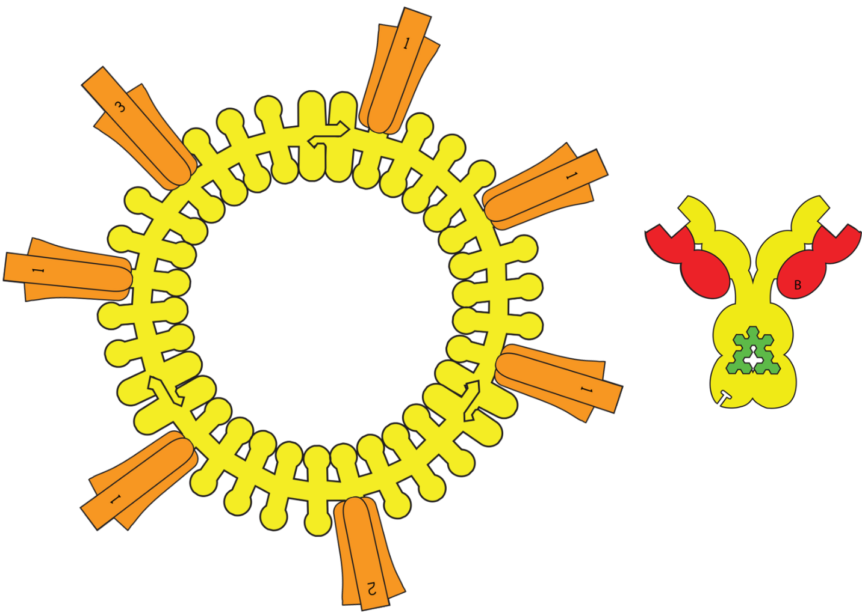
Model 3 (HIV)
You can model Human Immunodeficiency Virus (HIV) with this kit using the components shown above.

