Using the PROTEIN EXPORATORIUM… to explore the structure of the tip of the Long Tail Fiber of bacteriophage T4

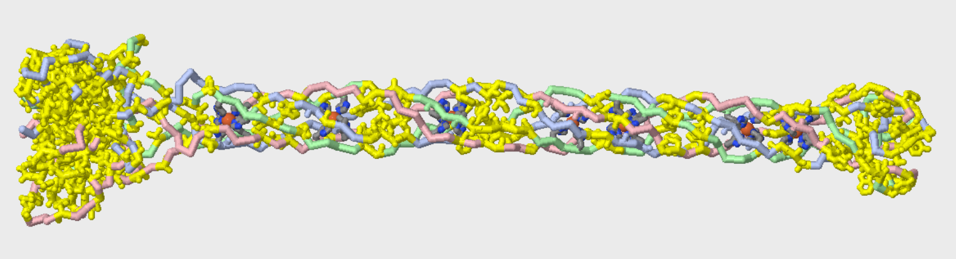
Remember seeing this model at last summer’s MII course?

This model… based on 2xgf.pdb… represents the structure of the protein that makes up the very tip of the Long Tail Fibers of bacteriophage T4
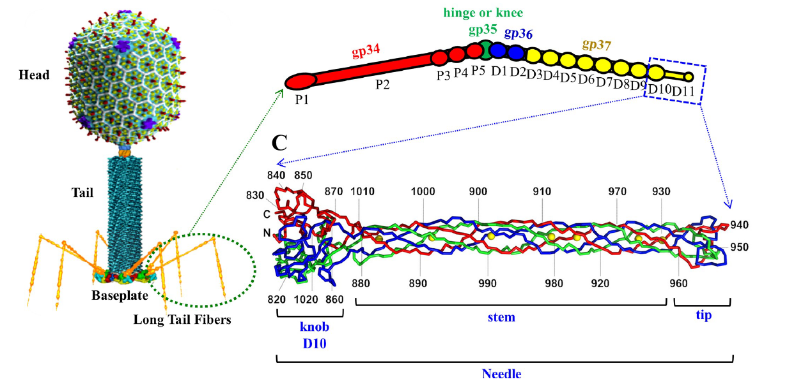

Primary citation…. describing the structure of the protein reported in 2xgf.pdb

Structure of the bacteriophage T4 long tail fiber receptor-binding tip. Bartual, S.G., Otero, J.M., Garcia-Doval, C., Llamas-Saiz, A.L., Kahn, R., Fox, G.C., van Raaij, M.J. (2010) Proc Natl Acad Sci U S A 107: 20287-20292 https://doi.org/10.1073/pnas.1011218107
The abstract from the primary citation reads….
Bacteriophages are the most numerous organisms in the biosphere. In spite of their biological significance and the spectrum of potential applications, little high-resolution structural detail is available on their receptor-binding fibers. Here we present the crystal structure of the receptor-binding tip of the bacteriophage T4 long tail fiber, which is highly homologous to the tip of the bacteriophage lambda side tail fibers. This structure reveals an unusual elongated six-stranded antiparallel beta-strand needle domain containing seven iron ions coordinated by histidine residues arranged colinearly along the core of the biological unit. At the end of the tip, the three chains intertwine forming a broader head domain, which contains the putative receptor interaction site. The structure reveals a previously unknown beta-structured fibrous fold, provides insights into the remarkable stability of the fiber, and suggests a framework for mutations to expand or modulate receptor-binding specificity.
While we can’t provide each of you with a copy of the physical model, the following Jmol commands – entered into the console of the Protein Exploratorium – will generate a Jmol image of this model.

- Log into your 3DMD account and launch the Protein Exploratorium (contact us if you are having trouble accessing the Protein Exploratorium)
- Load 2xgf
- Right-click in the Jmol window….and select “console”
Enter the following commands in the lower console window
- Select ligand and not CO3 (7 atoms will be selected)
- Spacefill
  - These commands will display the 7 iron atoms distributed along the tail fiber.
- Select his (420 atoms will be selected)
- Wireframe 200
  - These commands will display the 6 histidine sidechains that coordinate each iron atom.
- Select hydrophobic (2139 atoms will be selected)
- Wireframe 200
  - These commands will display the clusters of hydrophobic amino acids that distributed along the tail fiber… further stabilizing this six-stranded needle domain.
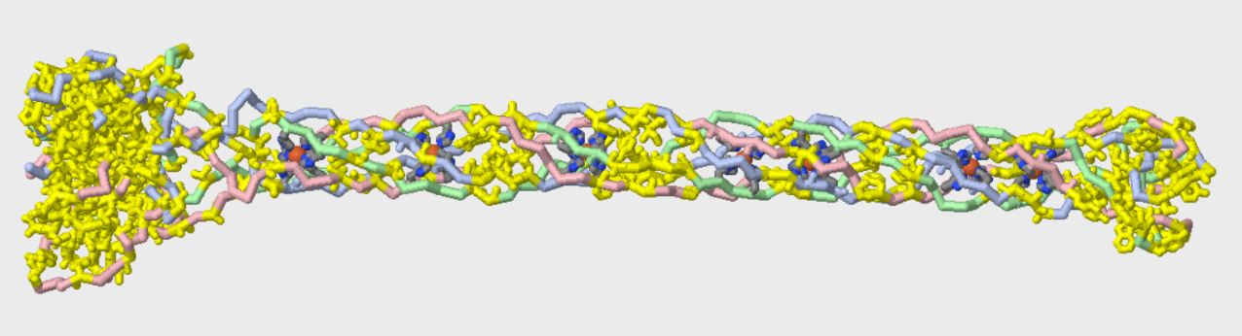
- ENJOY!

