Project: DNA Model, Protein Production & Mutations
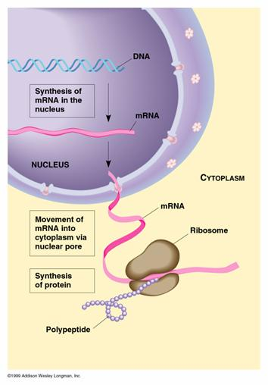
This is a protein
Overview of the Project
Your challenge is to turn the following graphic into a story about how DNA is the blueprint on how to build a protein. Create a video (no more than 4 min) to tell the story.

You will demonstrate the entire process of using DNA to express traits (i.e. features that determine what we look like & how our cells function).
You will
- Build a DNA strand,
- Identify an “active”gene
- Create a video/animation about how our cells turn a gene into a protein
- Simulate how mutations change genes

RESOURCES
PBS - Cracking the Code Clip:

Tour of the Basics
Please view the following video clips:
- What are traits?
- What are DNA and Genes?
- What is inheritance?
- What is a mutation?

Old Tour of the Basics
Please complete the following interactives:
- What is a protein?
- What is a chromosome?

Additional resources include:
- Transcription and Translation animation (as a good intro example)
- Mr. Anderson explains Transcription and Translation (12 min)
- http://learn.genetics.utah.edu/content/basics/transcribe/
- Making mRNA (transcription animation)
- Making proteins (translation animation)
- VCell - Translation (3+ mins)
- DNA Transcription and Translation video (7+ mins)

Part 1: Turning a Functional Gene into a Protein

What is the Structure of DNA?
Step 1: You have been given half of a DNA strand. Review the sequence on the strand & build a replica using the model kits. The model kits do not specify the components of nucleotides (phosphate, deoxyribose, and nitrogen bases) but do identify the nitrogen bases and locations for bonds amongst all parts of the nucleotide. You will be asked to label the specific parts later in this project.

Step 2: As you know, DNA is a double stranded polymer. You have only built 1 strand of DNA. You need to determine the complementary sequence to what you have built. Write the sequence on the Practice Worksheet.

How is DNA used to make an mRNA Transcript?
Step 1: Create a storyboard of the process cells use to “read” DNA and turn the DNA sequences into mRNA. The storyboard should be kept as your Notes.

Step 2: Identify the functional gene that you will use for the remainder of the project. It will be the half of the DNA that begins with an mRNA start Codon. Transcribe the functional gene from your DNA strand. Write the sequence of the mRNA transcript on your Practice Worksheet. Label this process “Transcription.”

Step 3: Create a video/animation of the process of Transcription using the model kits.

How is an mRNA transcript used to produce a Protein within a Ribosome?
Step 1: Create a storyboard of the process cells use to turn mRNA transcripts into proteins. The storyboard should be kept as your Notes

Step 2: Break your mRNA strip in three letter codons. Using the codon wheel, translate the functional gene from your mRNA strand. Write the amino acid (protein) on your Practice Worksheet and label this process “Translation.”

Step 3: Create a video/animation of the process of Translation using the model kits.

Project: DNA to Protein Video Rubric

Process | Several (50%) Requirements are not Met  UN | Some Requirements are not Met  BA | Requirements  PROFICIENT | Exceeded Requirements  DISTINGUISHED
What is the Structure of DNA? |  |  | Includes accurate labels for:  - 1 complete Nucleotide  - 3 parts of a Nucleotide
What is the Structure of DNA? |  |  | Accurately depicts complementary base pairs across the double strand (A-T and G-C)
How is DNA used to make an mRNA Transcript? |  |  | Accurately identifies the “Functional Gene” that will be transcribed (requires a Start Codon of AUG on the mRNA transcript);  - Will be on the “top” line when “unzipped”  - Unzipped DNA starts with TAC
How is DNA used to make an mRNA Transcript? |  |  | Includes accurate labels for:  - Nucleus  - DNA Template(unzipped portion)  - mRNA transcript  - Start Codon (MUST be AUG)
How is DNA used to make an mRNA Transcript? |  |  | Accurately pairs mRNA to the DNA template  - Makes the correct switch between T & U  - G-C  - Differentiate between ribose and deoxyribose sugars
How is DNA used to make an mRNA Transcript? |  |  | Finished video includes  - moving parts that clearly indicate the steps of Transcription;  - reasonable transitions that seem to “flow” between pictures;  - Voice over and/or labels support the video and describe what is happening.
How is an mRNA transcript used to make a Protein? |  |  | Includes accurate labels for:  - Ribosome  - mRNA Transcript  - tRNA  - Start Codon (MUST be AUG)  - Stop Codon  - Amino Acids (indicates individual circles)  - Protein (indicates long chain of circles)
How is an mRNA transcript used to make a Protein? |  |  | Finished video includes  - moving parts that clearly indicate the steps of Transcription;  - reasonable transitions that seem to “flow” between pictures;  - Voice over and/or labels support the video and describe what is happening.

